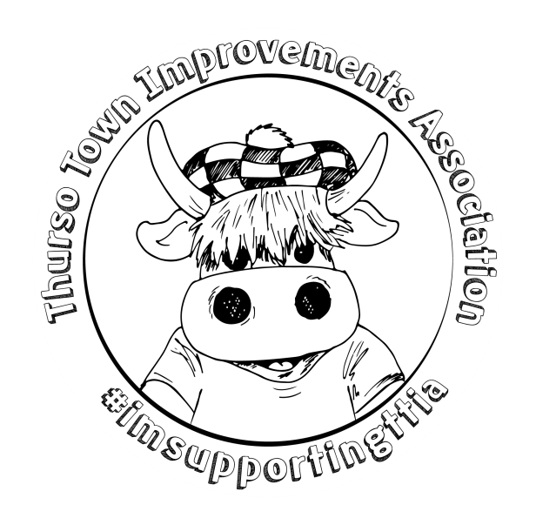
Summer 2017 Round up:
- We hope you had a good summer, as autumn appears we don’t seem to have been too bothered by the sun in Thurso but hopefully you enjoyed it anyhow.
- As you may have seen, we’ve tried to change the format of some of our activities. The Mid-Summer Madness event seems to have been popular with the community which we’re thrilled about. We kept many of the traditional gala week events but have opted to host them throughout the year to ease pressure on our volunteers as well as folks finances and Summer plans.
- Through a competition, we unveiled our mascot. Thurso’s Tia (If you wondered where the name came from think of our initials.) She has proven popular and we hope she will make many appearances at local events. If you haven’t seen her yet have a trawl of our Facebook page where you’ll find images of her. There is even a wee movie clip on her arrival in Thurso and her weekend at Mid Summer Madness.
Onwards and Upwards!
- Next up we’ll host our Halloween celebrations with two children’s parties and an adults Halloween party in the Central Function Suite. Keep an eye on our Facebook page where we’ll advertise where to get your outfits and accessories from locally. You can book to have your Halloween make up done by Enhance By SLS now who has kindly agreed to offer TTIA 20% from each Halloween booking.
- We’re interested in trying something new in the October holidays. We would like to try “Tia’s Guys” competition (as in Guy Fawkes) running from the start of the School Holidays (7th) through to November 3^{rd.} All shops, businesses and organisations have been invited to make a Guy and present it either outside their shop or inside the window. We’ll advertise those taking part so you all know where to look. It’s similar to the scarecrow festivals which you see in Golspie and Brora. The winner will be chosen by public vote via our social media.
Christmas in Thurso (yes, we said it far too early, we’re sorry!)
- Christmas Jumper Day is BACK! On Friday 1st December we encourage all types of silly and fun Christmas behaviour in offices, shops, schools, workplaces-the lot! We ask you to wear a Christmas jumper or whatever you can get your hands on and make a donation to TTIA for taking part. It’s been great fun and a real community spirit booster in the past, the perfect setting for the following trader’s day. Donations can be made in person or via our website.
- We are changing our typical Christmas schedule. We’re moving our Christmas Lights switch on to Sunday 3rd December. The Main Street Christmas lights will be on for Traders day but we will light the tree and Sir Johns Square on the 3rd.
- Santa and his Grotto will be in Caithness Horizons Museum as usual on Saturday 2nd December and will welcome nursery and early school age children during the week before hosting ‘Tea with Santa’ on Saturday 9th December. This event gives adults an opportunity to see the children’s artwork on display in the grotto. The grotto is not normally open to the public so the idea is to allow folk to see the space transformed for the children. Tickets will be available nearer the time.
- Our Christmas Decoration Window Hunt will take place throughout December. Dates TBC.
There will be a Decorated Window Competition for you to see when you are hunting for those Christmas Decorations.

- The Christmas Tree Lights Switch On will take place after a Street Parade from Caithness Horizons through the precinct, around the town centre and finishing at the town’s square. It takes place on the afternoon of Sunday 3rd December. The event will feature youth groups, themed decorated floats, music and hopefully increase the communities Christmas spirit. We intend to have some stalls selling seasonal food and drink and we are hopeful that the local shops will open and join in this Christmas community celebration.
- We’re offering a new event called Bring A Party To A Party on Friday 8th December. Tickets are available now. The evening consists of Dinner, Christmas Disco and a live band dance with Frayed Edges. The event starts at 7 pm in the Legion. This gives folk an opportunity to support TTIA and the Thurso Legion while enjoying their Christmas party night. A good deed and enjoying a night out at the same time?! Sign us up! For more details or to book tickets, please contact us.
- We will close our 2017 Christmas In Thurso celebrations with Santa and his sleigh visiting various sites around Thurso. Santa will be on the move and would be delighted to see lots of faces come to say hello. Dates and stop off points will be advertised closer to the time.
2018 Plans and adventures
- We won’t be long into the new year when we will be having our first event of a busy 2018. On Thursday 25th January, we’ll host our Senior Citizens Burns Night. An evening of Haggis, Neeps & tatties followed by some entertainment. This event is for our deserving senior members of the community. Free tickets will be available from Caithness Horizons on a first come, first served basis so keep checking our social media for announcements.
- Thereafter, we’ll have completed a full year as our new committee. We’ll be ready to take on our children’s Easter party and the shop window Easter Egg hunt as well as looking forward to the second MidSummer Madness event.

Our events are aimed at raising funds for our community projects which were selected through public consultation ‘Thurso Riverside Illumination Project’ (TRIP) aims to light between the footbridges around Thurso Mall so it can become an all year-round amenity for walkers, runners, dog walkers locals and visitors to use and view our fantastic riverside. Our secondary project is to recognise familiar faces and local heroes of Thurso on plaques which will create a scenic walk around town.

Details of all our upcoming events will be available on our new look website: www.thurso.org and on our Facebook page if you search for Thurso Town Improvements Association. You can contact us by e-mail to: thursotownimprovements@gmail.com and can sign up to our mailing list to receive our information direct to your e-mail inbox. You can join the mailing list via the website.

We hope you like the changes we’re making. We appreciate all feedback to improve our events and how they can benefit our community. Feel free to share your thoughts and ideas with us and where practicable we will try and adopt them into our plans

If you would like to volunteer to help us it would be fantastic to have you as part of our team. Please email us your contact details and we will put you on our volunteers list and keep you informed.

